TC ENGINEERING SERVICES
And Portobello engineering

REFERENCES OF
COOLING SYSTEM INSTALLATIONS

References of Cooling Tower Installations

The following list gives a number of reference sites in which Carters have carried out water cooling installations. All the following references are willing to be contacted and/or visited to view their particular installations.

1) Cargills Grain – Hull

Contact Name: Mark Swift
Telephone Number: 01482 608023

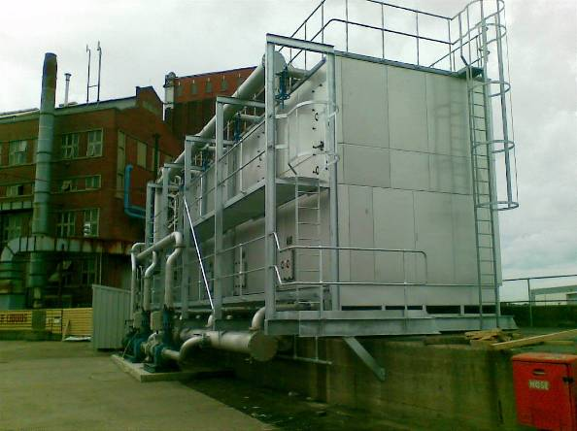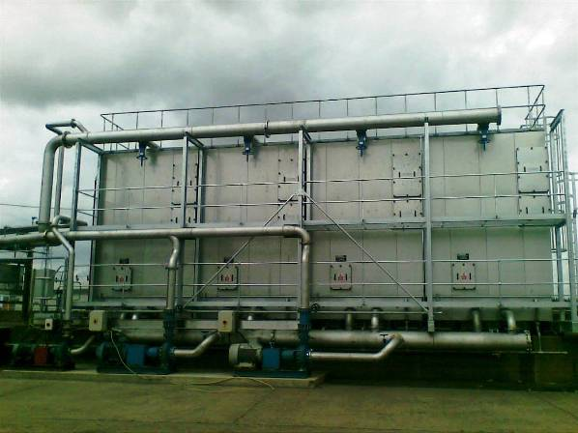

2) Croda Chemicals – Rawcliffe Bridge

Contact Name: was Sajid Khan (now Paul Jarrett)
Telephone Number: 01405 863400

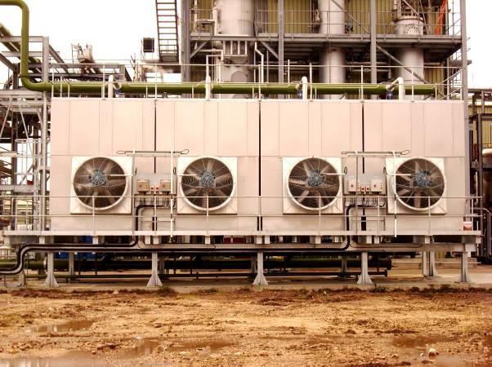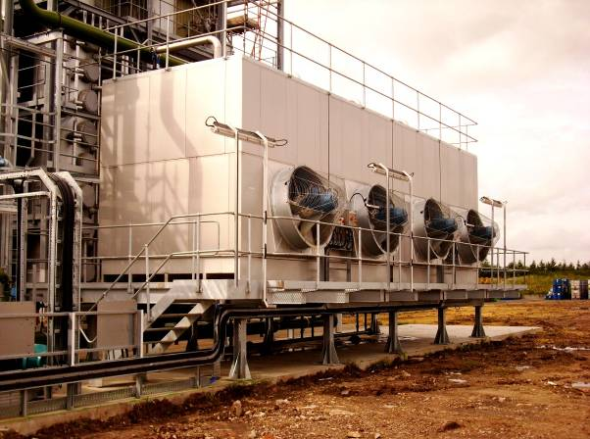

3) Bluestar Fibres – Grimsby

Contact Name: Gary Howden
Telephone Number: 01472 244277

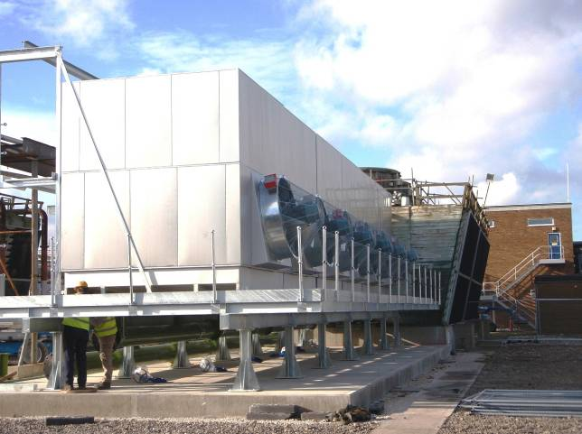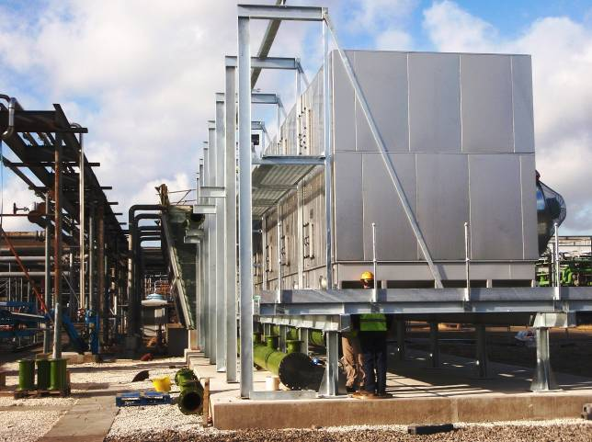

4) Rockwood Pigments – Birtley

Contact Name: Andrew Morris
Telephone Number: 0191 492 9543

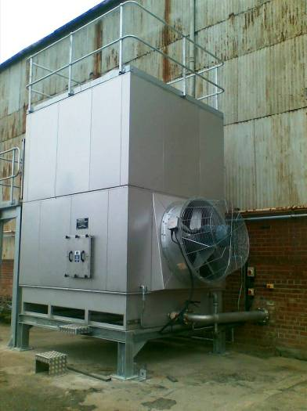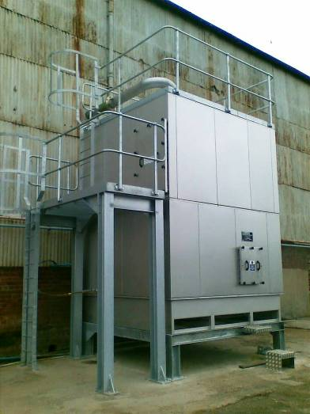

5) NXP Semiconductors – Hazel Grove

Contact Name: Mike Dawson or Alf Moores
Telephone Number: 0161 957 5599 or 0191 957 5495

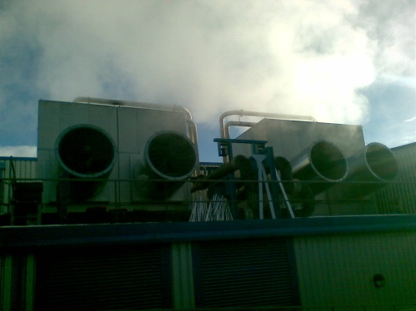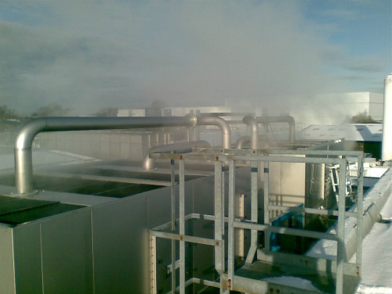

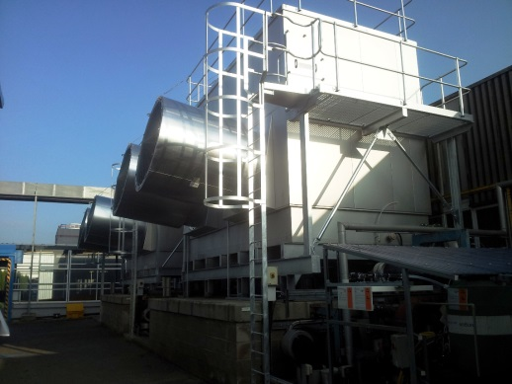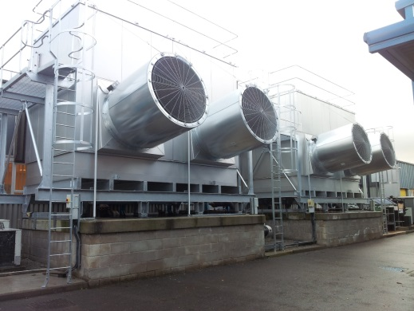

6) Erasteel Stubs – Warrington

Contact Name: John Luty
Telephone Number: 07977 104571

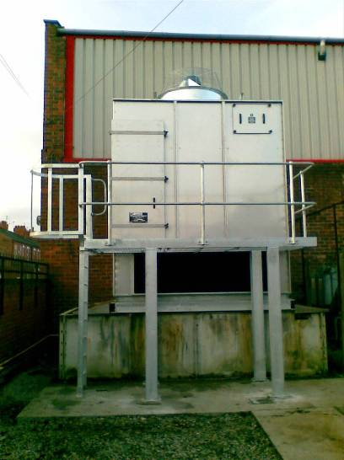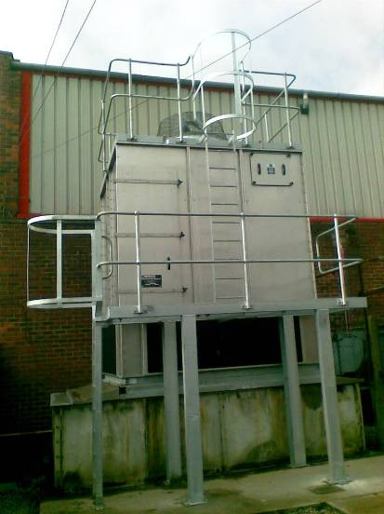

7) Pirelli Tyres – Carlisle

Contact Name – John Blair
Telephone Number – 07974 153949
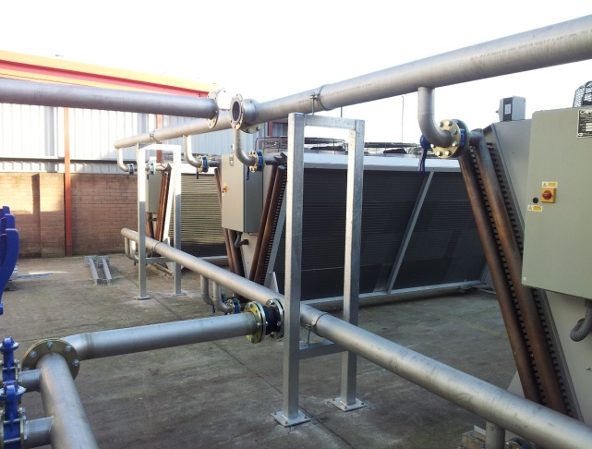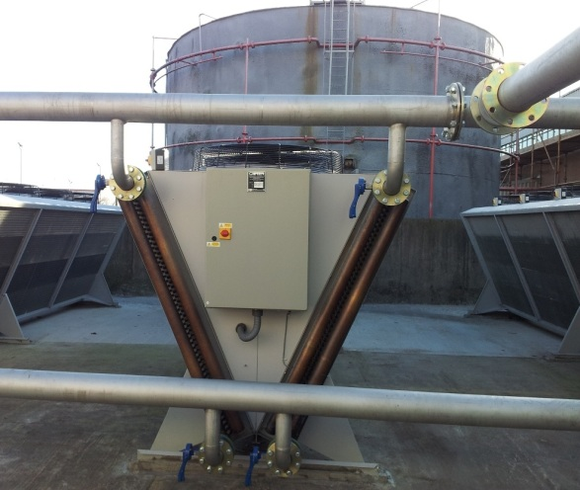

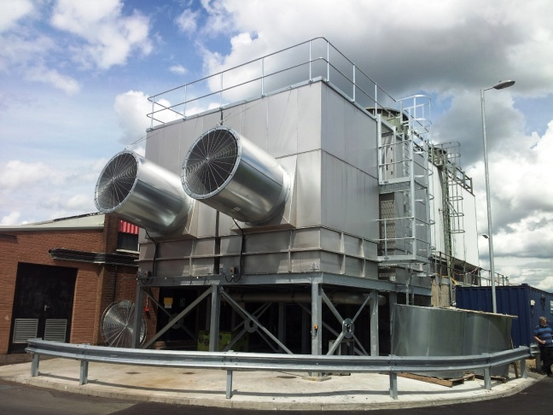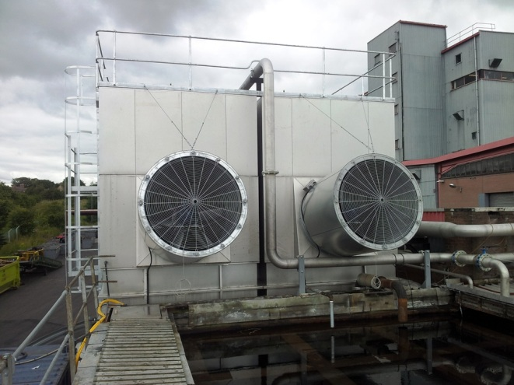

8) Bridon Wire, Doncaster

Contact: Bob Colemen
Telephone:- 07827 293845

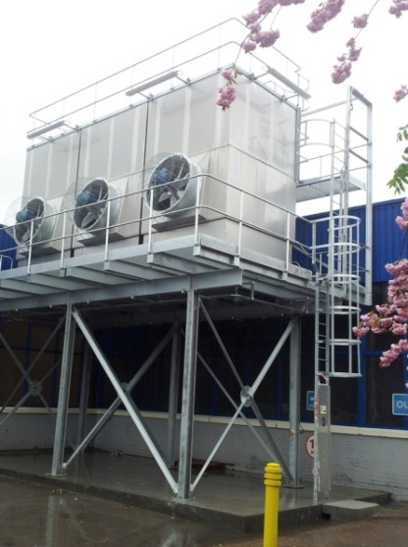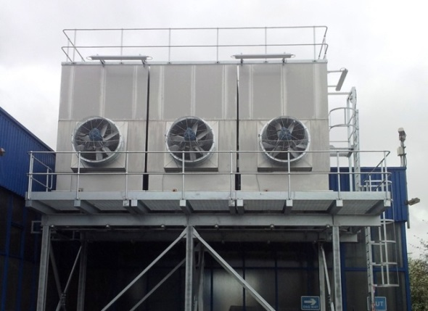

8) Kepston Ltd – Wednesbury

Contact Name – Tony Smith
Telephone Number – 07766 776996

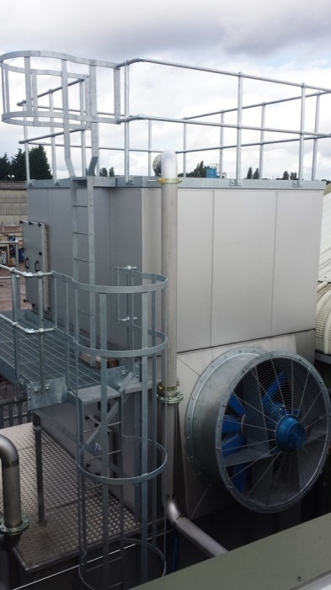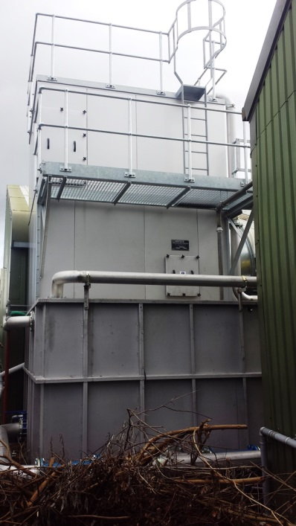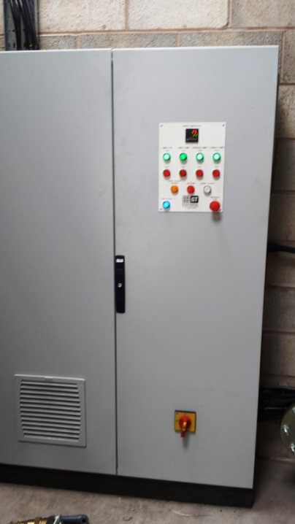

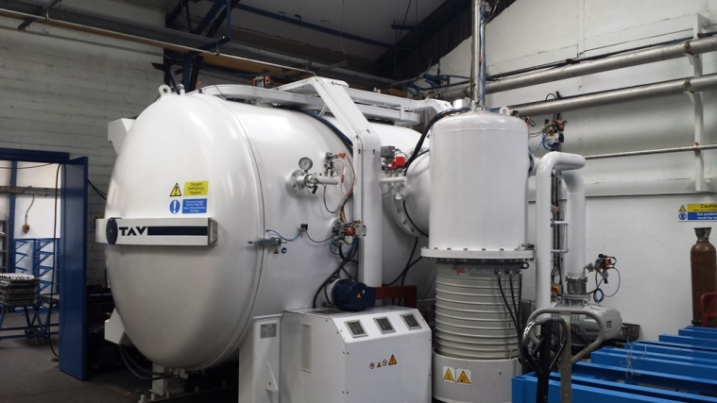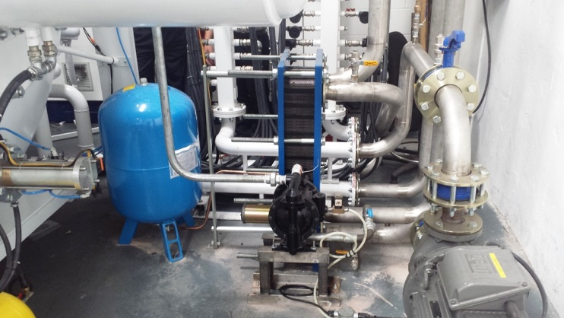

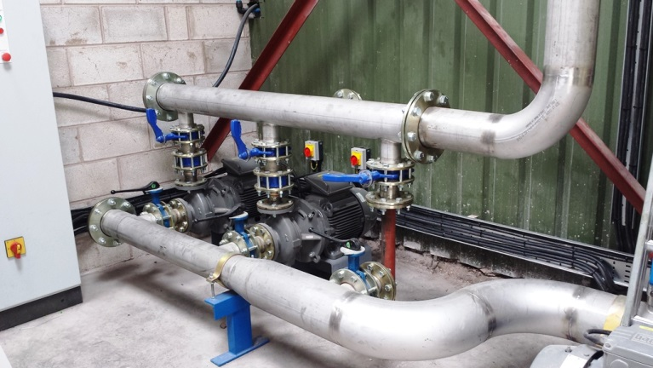

Others include

Tennants, Glasgow
Toyota Deeside
Toyota Derby
Cummins Engines Darlington
Tata Steel Stocksbridge
FMC Lithium Wirral
Urenco Capenhurst
Dacrylate, Kirkby in Ashfield
VIP Polymers, Huntingdon
Bobst, Heywood

